**EX.NO:9 DATE: 13.03.2025**

**OBJECT DETECTION**

**Aim:**

To perform image classification (cats vs. dogs) using HOG features and SVM, and to detect objects in images using SIFT features, feature matching, homography, and K-Means clustering.  
**Algorithm:**

**1. Image Classification Using HOG and SVM**

**Algorithm**:

1. Load & Resize Images: Grayscale images loaded from folders and resized.
2. Extract HOG Features: HOG features extracted using skimage.feature.hog.
3. Dataset Split: Data split into training and testing sets.
4. SVM Training: Linear SVM classifier trained.
5. Prediction & Evaluation: Model predicts on test data; accuracy and report generated.

**2. Object Detection Using SIFT and Homography (First Instance)**

**Algorithm**:

1. Prepare Images: Training and test images loaded & converted to grayscale.
2. Detect Features: SIFT detects keypoints & computes descriptors.
3. Match Keypoints: BFMatcher finds matches; Lowe's ratio test filters.
4. Find Homography: RANSAC estimates homography matrix.
5. Detect Object: Bounding box drawn using homography.
6. Display Results: Image shown with bounding box.

**3. Object Detection Using SIFT and Homography (Second Instance)**

**Algorithm**:

1. Initialization: SIFT detector and BFMatcher initialized.
2. Feature Matching: KNN matching with Lowe's ratio test.
3. Homography Estimation: RANSAC estimates homography (if enough matches).
4. Object Localization: Object corners transformed using homography.
5. Visualization: Bounding box drawn; feature matches displayed.

**4. Object Detection Using SIFT, Feature Matching, and K-Means Clustering**

**Algorithm**:

1. Feature Matching: Matches found via BFMatcher and Lowe's ratio.
2. Keypoint Extraction: Matched keypoint coordinates extracted.
3. K-Means Clustering: Keypoints clustered into *k* groups.
4. Bounding Box Creation: Bounding boxes defined around each cluster.
5. Visualization: Training image shown with bounding boxes.

**Code:**

import cv2  
import numpy as np  
import matplotlib.pyplot as plt  
  
def detect_and_match_objects(reference_image_path, query_image_path, min_match_count=10):  
 Detect objects in a query image based on a reference image using SIFT features.  
  
 Parameters:  
 reference_image_path (str): Path to the reference image (object to be detected)  
 query_image_path (str): Path to the query image (where to find the object)  
 min_match_count (int): Minimum number of good matches required  
  
 Returns:  
 tuple: (result_image, homography_matrix, matches_mask)  
 reference_img = cv2.imread(reference_image_path)  
 query_img = cv2.imread(query_image_path)  
  
 reference_gray = cv2.cvtColor(reference_img, cv2.COLOR_BGR2GRAY)  
 query_gray = cv2.cvtColor(query_img, cv2.COLOR_BGR2GRAY)  
  
 sift = cv2.SIFT_create()  
  
 kp_reference, des_reference = sift.detectAndCompute(reference_gray, None)  
 kp_query, des_query = sift.detectAndCompute(query_gray, None)  
  
 FLANN_INDEX_KDTREE = 1  
 index_params = dict(algorithm=FLANN_INDEX_KDTREE, trees=5)  
 search_params = dict(checks=50)  
  
 flann = cv2.FlannBasedMatcher(index_params, search_params)  
  
 matches = flann.knnMatch(des_reference, des_query, k=2)  
  
 good_matches = []  
 for m, n in matches:  
 if m.distance < 0.7 * n.distance:  
 good_matches.append(m)  
  
 matches_mask = [[0, 0] for _ in range(len(matches))]  
  
 homography = None  
 if len(good_matches) >= min_match_count:  
 src_pts = np.float32([kp_reference[m.queryIdx].pt for m in good_matches]).reshape(-1, 1, 2)  
 dst_pts = np.float32([kp_query[m.trainIdx].pt for m in good_matches]).reshape(-1, 1, 2)  
  
 homography, mask = cv2.findHomography(src_pts, dst_pts, cv2.RANSAC, 5.0)  
  
 for i, (m, _) in enumerate(matches):  
 if m in good_matches and mask[good_matches.index(m)]:  
 matches_mask[i] = [1, 0]  
  
 h, w = reference_gray.shape  
 corners = np.float32([[0, 0], [0, h-1], [w-1, h-1], [w-1, 0]]).reshape(-1, 1, 2)  
 transformed_corners = cv2.perspectiveTransform(corners, homography)  
  
 result_img = query_img.copy()  
 cv2.polylines(result_img, [np.int32(transformed_corners)], True, (0, 255, 0), 3)  
  
 print(f"Object found - {len(good_matches)} good matches")  
 else:  
 print(f"Not enough matches found - {len(good_matches)}/{min_match_count}")  
 result_img = query_img.copy()  
 homography = None  
  
 return result_img, homography, matches_mask  
  
def visualize_keypoints(image_path):  
 Visualize SIFT keypoints on an image  
  
 Parameters:  
 image_path (str): Path to the image  
  
 Returns:  
 numpy.ndarray: Image with keypoints drawn  
 img = cv2.imread(image_path)  
 gray = cv2.cvtColor(img, cv2.COLOR_BGR2GRAY)  
  
 sift = cv2.SIFT_create()  
 keypoints = sift.detect(gray, None)  
  
 img_with_keypoints = cv2.drawKeypoints(gray, keypoints, None, flags=cv2.DRAW_MATCHES_FLAGS_DRAW_RICH_KEYPOINTS)  
  
 return img_with_keypoints  
  
def visualize_matches(reference_image_path, query_image_path):  
 Visualize matches between reference and query images  
  
 Parameters:  
 reference_image_path (str): Path to the reference image  
 query_image_path (str): Path to the query image  
  
 Returns:  
 numpy.ndarray: Image showing matches  
 reference_img = cv2.imread(reference_image_path)  
 query_img = cv2.imread(query_image_path)  
  
 reference_gray = cv2.cvtColor(reference_img, cv2.COLOR_BGR2GRAY)  
 query_gray = cv2.cvtColor(query_img, cv2.COLOR_BGR2GRAY)  
  
 sift = cv2.SIFT_create()  
  
 kp_reference, des_reference = sift.detectAndCompute(reference_gray, None)  
 kp_query, des_query = sift.detectAndCompute(query_gray, None)  
  
 FLANN_INDEX_KDTREE = 1  
 index_params = dict(algorithm=FLANN_INDEX_KDTREE, trees=5)  
 search_params = dict(checks=50)  
  
 flann = cv2.FlannBasedMatcher(index_params, search_params)  
  
 matches = flann.knnMatch(des_reference, des_query, k=2)  
  
 good_matches = []  
 for m, n in matches:  
 if m.distance < 0.7 * n.distance:  
 good_matches.append(m)  
  
 img_matches = cv2.drawMatches(reference_img, kp_reference, query_img, kp_query, good_matches, None,  
 flags=cv2.DrawMatchesFlags_NOT_DRAW_SINGLE_POINTS)  
  
 return img_matches  
  
if __name__ == "__main__":  
 reference_image = "ref.png"  
 query_image = "shoe.jpg"  
  
 result, homography, matches_mask = detect_and_match_objects(reference_image, query_image)  
  
 result_rgb = cv2.cvtColor(result, cv2.COLOR_BGR2RGB)  
  
 reference_keypoints = visualize_keypoints(reference_image)  
 reference_keypoints_rgb = cv2.cvtColor(reference_keypoints, cv2.COLOR_BGR2RGB)  
  
 matches_visualization = visualize_matches(reference_image, query_image)  
 matches_visualization_rgb = cv2.cvtColor(matches_visualization, cv2.COLOR_BGR2RGB)  
  
 plt.figure(figsize=(15, 10))  
  
 plt.subplot(2, 2, 1)  
 plt.imshow(cv2.cvtColor(cv2.imread(reference_image), cv2.COLOR_BGR2RGB))  
 plt.title('Reference Image')  
 plt.axis('off')  
  
 plt.subplot(2, 2, 2)  
 plt.imshow(cv2.cvtColor(cv2.imread(query_image), cv2.COLOR_BGR2RGB))  
 plt.title('Query Image')  
 plt.axis('off')  
  
 plt.subplot(2, 2, 3)  
 plt.imshow(reference_keypoints_rgb)  
 plt.title('SIFT Keypoints on Reference Image')  
 plt.axis('off')  
  
 plt.subplot(2, 2, 4)  
 plt.imshow(result_rgb)  
 plt.title('Object Detection Result')  
 plt.axis('off')  
  
 plt.tight_layout()  
 plt.show()  
  
 plt.figure(figsize=(15, 10))  
 plt.imshow(matches_visualization_rgb)  
 plt.title('Feature Matches')  
 plt.axis('off')  
 plt.show()

Object found - 91 good matches

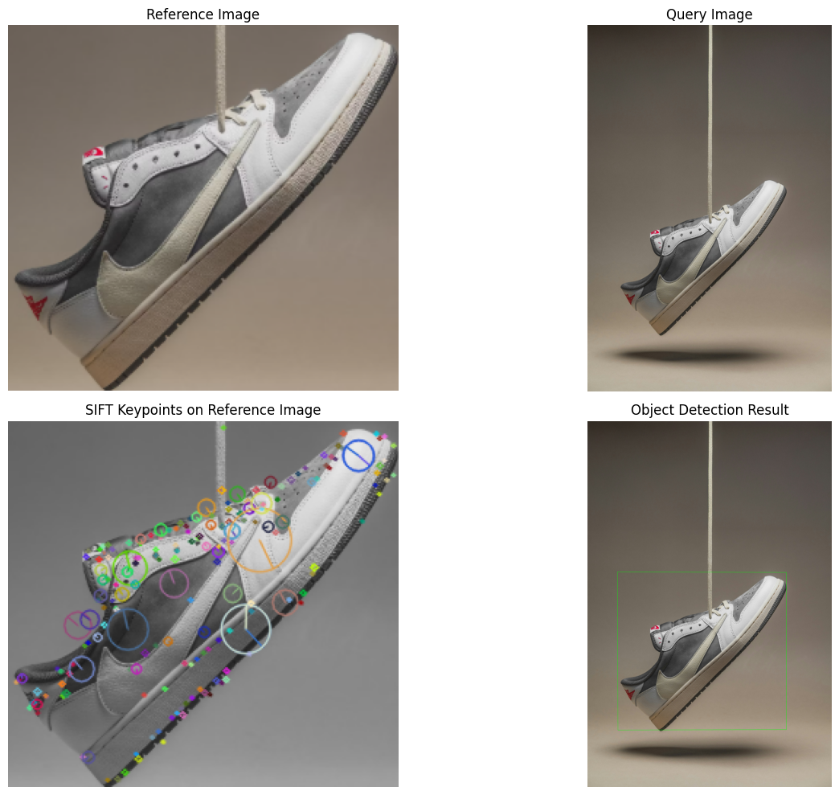

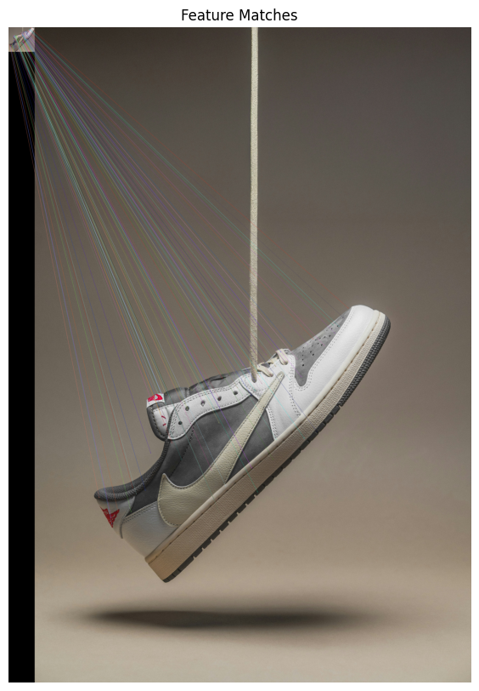

import cv2  
import numpy as np  
import matplotlib.pyplot as plt  
from skimage.feature import hog  
from skimage import exposure  
from scipy import ndimage  
  
def compute_sift_features(image):  
 Compute SIFT features for the given image  
 if len(image.shape) == 3:  
 gray = cv2.cvtColor(image, cv2.COLOR_BGR2GRAY)  
 else:  
 gray = image  
  
 sift = cv2.SIFT_create()  
  
 keypoints, descriptors = sift.detectAndCompute(gray, None)  
  
 return keypoints, descriptors  
  
def compute_hog_features(image, orientations=9, pixels_per_cell=(8, 8), cells_per_block=(2, 2)):  
 Compute HOG features for the given image  
 if len(image.shape) == 3:  
 gray = cv2.cvtColor(image, cv2.COLOR_BGR2GRAY)  
 else:  
 gray = image  
  
 hog_features, hog_image = hog(  
 gray,  
 orientations=orientations,  
 pixels_per_cell=pixels_per_cell,  
 cells_per_block=cells_per_block,  
 visualize=True,  
 block_norm='L2-Hys'  
 )  
  
 hog_image_rescaled = exposure.rescale_intensity(hog_image, in_range=(0, 10))  
  
 return hog_features, hog_image_rescaled  
  
def compute_gloh_features(image, keypoints):  
 Compute GLOH features for the given image and keypoints  
 GLOH is an extension of SIFT that uses a log-polar location grid with 3 bins in radial  
 direction and 8 in angular direction, giving 17 location bins (including the central bin)  
 if len(image.shape) == 3:  
 gray = cv2.cvtColor(image, cv2.COLOR_BGR2GRAY)  
 else:  
 gray = image  
  
 gloh_descriptors = []  
  
 num_radial_bins = 3  
 num_angular_bins = 8  
 num_orientation_bins = 8  
 radius_max = 20   
  
 for kp in keypoints:  
 x, y = int(kp.pt[0]), int(kp.pt[1])  
 scale = kp.size  
 orientation = kp.angle  
  
 if x < radius_max or y < radius_max or x >= gray.shape[1] - radius_max or y >= gray.shape[0] - radius_max:  
 continue  
  
 patch = gray[y-radius_max:y+radius_max, x-radius_max:x+radius_max]  
  
 dx = ndimage.sobel(patch, axis=1)  
 dy = ndimage.sobel(patch, axis=0)  
  
 magnitude = np.sqrt(dx**2 + dy**2)  
 orientation_map = np.arctan2(dy, dx) * 180 / np.pi % 360  
  
 y_grid, x_grid = np.ogrid[-radius_max:radius_max, -radius_max:radius_max]  
 r_grid = np.sqrt(x_grid**2 + y_grid**2)  
 theta_grid = (np.arctan2(y_grid, x_grid) * 180 / np.pi) % 360  
  
 radial_bins = np.zeros(num_radial_bins + 1)  
 radial_bins[0] = 0  
 radial_bins[1] = radius_max / 3  
 radial_bins[2] = radius_max * 2 / 3  
 radial_bins[3] = radius_max  
  
 descriptor = np.zeros((1 + num_radial_bins * num_angular_bins) * num_orientation_bins)  
  
 central_mask = r_grid < radial_bins[1]  
 for o in range(num_orientation_bins):  
 orient_min = o * 360 / num_orientation_bins  
 orient_max = (o + 1) * 360 / num_orientation_bins  
 orient_mask = (orientation_map >= orient_min) & (orientation_map < orient_max)  
 mask = central_mask & orient_mask  
 descriptor[o] = np.sum(magnitude[mask])  
  
 descriptor_idx = num_orientation_bins  
 for r in range(1, num_radial_bins):  
 radial_mask = (r_grid >= radial_bins[r]) & (r_grid < radial_bins[r+1])  
 for a in range(num_angular_bins):  
 angle_min = a * 360 / num_angular_bins  
 angle_max = (a + 1) * 360 / num_angular_bins  
 angle_mask = (theta_grid >= angle_min) & (theta_grid < angle_max)  
 for o in range(num_orientation_bins):  
 orient_min = o * 360 / num_orientation_bins  
 orient_max = (o + 1) * 360 / num_orientation_bins  
 orient_mask = (orientation_map >= orient_min) & (orientation_map < orient_max)  
 mask = radial_mask & angle_mask & orient_mask  
 descriptor[descriptor_idx] = np.sum(magnitude[mask])  
 descriptor_idx += 1  
  
 norm = np.linalg.norm(descriptor)  
 if norm > 0:  
 descriptor /= norm  
  
 gloh_descriptors.append(descriptor)  
  
 return np.array(gloh_descriptors) if gloh_descriptors else None  
  
def detect_objects(query_image, target_image, min_match_count=10):  
 Detect objects in target image using features from query image  
 kp1, des1 = compute_sift_features(query_image)  
  
 kp2, des2 = compute_sift_features(target_image)  
  
 FLANN_INDEX_KDTREE = 1  
 index_params = dict(algorithm=FLANN_INDEX_KDTREE, trees=5)  
 search_params = dict(checks=50)  
 flann = cv2.FlannBasedMatcher(index_params, search_params)  
  
 matches = flann.knnMatch(des1, des2, k=2)  
  
 good_matches = []  
 for m, n in matches:  
 if m.distance < 0.7 * n.distance:  
 good_matches.append(m)  
  
 if len(good_matches) >= min_match_count:  
 src_pts = np.float32([kp1[m.queryIdx].pt for m in good_matches]).reshape(-1, 1, 2)  
 dst_pts = np.float32([kp2[m.trainIdx].pt for m in good_matches]).reshape(-1, 1, 2)  
  
 M, mask = cv2.findHomography(src_pts, dst_pts, cv2.RANSAC, 5.0)  
 matchesMask = mask.ravel().tolist()  
  
 h, w = query_image.shape[:2]  
 pts = np.float32([[0, 0], [0, h-1], [w-1, h-1], [w-1, 0]]).reshape(-1, 1, 2)  
  
 dst = cv2.perspectiveTransform(pts, M)  
  
 result_image = target_image.copy()  
 cv2.polylines(result_image, [np.int32(dst)], True, (0, 255, 0), 3, cv2.LINE_AA)  
  
 draw_params = dict(  
 matchColor=(0, 255, 0),

singlePointColor=None,  
 matchesMask=matchesMask, # Only draw matched keypoints  
 flags=2  
 )  
  
 match_image = cv2.drawMatches(query_image, kp1, target_image, kp2, good_matches, None, **draw_params)  
  
 return True, result_image, match_image  
 else:  
 print("Not enough good matches: {}/{}".format(len(good_matches), min_match_count))  
 return False, target_image, None  
  
def main():  
 query_image = cv2.imread('ref.png')  
 target_image = cv2.imread('shoe.jpg')  
  
 if query_image is None or target_image is None:  
 print("Error: Could not load one or both images")  
 return  
  
 success, result_image, match_image = detect_objects(query_image, target_image)  
  
 _, hog_image_query = compute_hog_features(query_image)  
 _, hog_image_target = compute_hog_features(target_image)  
  
 keypoints_query, _ = compute_sift_features(query_image)  
 keypoints_target, _ = compute_sift_features(target_image)  
  
 gloh_descriptors_query = compute_gloh_features(query_image, keypoints_query)  
 gloh_descriptors_target = compute_gloh_features(target_image, keypoints_target)  
  
 sift_image_query = cv2.drawKeypoints(  
 query_image,  
 keypoints_query,  
 None,  
 flags=cv2.DRAW_MATCHES_FLAGS_DRAW_RICH_KEYPOINTS  
 )  
  
 sift_image_target = cv2.drawKeypoints(  
 target_image,  
 keypoints_target,  
 None,  
 flags=cv2.DRAW_MATCHES_FLAGS_DRAW_RICH_KEYPOINTS  
 )  
  
 plt.figure(figsize=(15, 10))  
  
 plt.subplot(331), plt.imshow(cv2.cvtColor(query_image, cv2.COLOR_BGR2RGB))  
 plt.title('Query Image'), plt.xticks([]), plt.yticks([])  
  
 plt.subplot(332), plt.imshow(hog_image_query, cmap='gray')  
 plt.title('Query HOG Features'), plt.xticks([]), plt.yticks([])  
  
 plt.subplot(333), plt.imshow(cv2.cvtColor(sift_image_query, cv2.COLOR_BGR2RGB))  
 plt.title('Query SIFT Keypoints'), plt.xticks([]), plt.yticks([])  
  
 plt.subplot(334), plt.imshow(cv2.cvtColor(target_image, cv2.COLOR_BGR2RGB))  
 plt.title('Target Image'), plt.xticks([]), plt.yticks([])  
  
 plt.subplot(335), plt.imshow(hog_image_target, cmap='gray')  
 plt.title('Target HOG Features'), plt.xticks([]), plt.yticks([])  
  
 plt.subplot(336), plt.imshow(cv2.cvtColor(sift_image_target, cv2.COLOR_BGR2RGB))  
 plt.title('Target SIFT Keypoints'), plt.xticks([]), plt.yticks([])  
  
 if success:  
 plt.subplot(337), plt.imshow(cv2.cvtColor(match_image, cv2.COLOR_BGR2RGB))  
 plt.title('Feature Matches'), plt.xticks([]), plt.yticks([])  
  
 plt.subplot(338), plt.imshow(cv2.cvtColor(result_image, cv2.COLOR_BGR2RGB))  
 plt.title('Object Detection Result'), plt.xticks([]), plt.yticks([])  
  
 plt.tight_layout()  
 plt.show()  
  
 print(f"Number of SIFT keypoints in query image: {len(keypoints_query)}")  
 print(f"Number of SIFT keypoints in target image: {len(keypoints_target)}")  
  
 if gloh_descriptors_query is not None:  
 print(f"Number of GLOH descriptors in query image: {len(gloh_descriptors_query)}")  
  
 if gloh_descriptors_target is not None:  
 print(f"Number of GLOH descriptors in target image: {len(gloh_descriptors_target)}")  
  
 if success:  
 print("Object successfully detected in target image!")  
 else:  
 print("Object detection failed.")  
  
if __name__ == "__main__":  
 main()

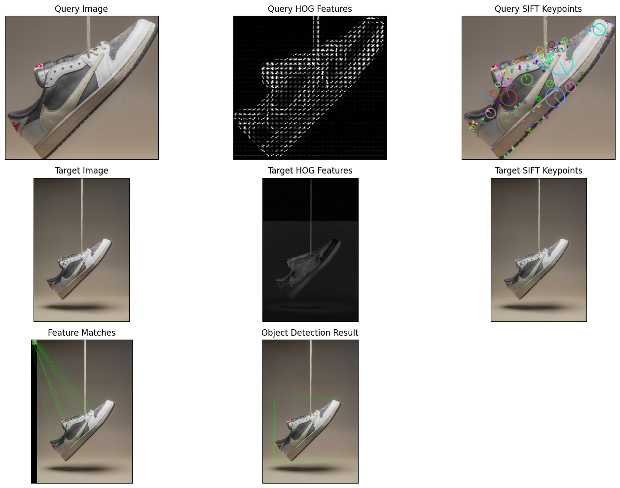

Number of SIFT keypoints in query image: 206  
Number of SIFT keypoints in target image: 53823  
Number of GLOH descriptors in query image: 180  
Number of GLOH descriptors in target image: 53816  
Object successfully detected in target image!

import numpy as np  
import cv2  
import os  
import glob  
import matplotlib.pyplot as plt  
from skimage.feature import hog  
from sklearn.model_selection import train_test_split  
from sklearn.svm import SVC  
from sklearn.metrics import accuracy_score, classification_report  
  
def load_images_from_folder(folder, label):  
 images = []  
 labels = []  
 for filename in glob.glob(os.path.join(folder, "*.jpg")):   
 img = cv2.imread(filename, cv2.IMREAD_GRAYSCALE)   
 if img is not None:  
 img = cv2.resize(img, (64, 64))   
 images.append(img)  
 labels.append(label)  
 return images, labels  
  
cat_images, cat_labels = load_images_from_folder("drive/MyDrive/Datasets/catsAndDogs40/train/cat", label=0)  
dog_images, dog_labels = load_images_from_folder("drive/MyDrive/Datasets/catsAndDogs40/train/dog", label=1)  
  
X = np.array(cat_images + dog_images)  
y = np.array(cat_labels + dog_labels)  
  
hog_features = []  
for image in X:  
 feature, _ = hog(image, pixels_per_cell=(8, 8), cells_per_block=(2, 2), visualize=True)  
 hog_features.append(feature)  
  
X_hog = np.array(hog_features)  
  
X_train, X_test, y_train, y_test = train_test_split(X_hog, y, test_size=0.2, random_state=42)  
  
svm_model = SVC(kernel='linear')  
svm_model.fit(X_train, y_train)  
  
y_pred = svm_model.predict(X_test)  
  
accuracy = accuracy_score(y_test, y_pred)  
print("Model Accuracy:", accuracy)  
print("\nClassification Report:\n", classification_report(y_test, y_pred))

Model Accuracy: 0.6153846153846154  
  
Classification Report:  
 precision recall f1-score support  
  
 0 0.67 0.33 0.44 6  
 1 0.60 0.86 0.71 7  
  
 accuracy 0.62 13  
 macro avg 0.63 0.60 0.58 13  
weighted avg 0.63 0.62 0.59 13

def predict_image(image_path, model):  
 img = cv2.imread(image_path, cv2.IMREAD_GRAYSCALE) # Convert to grayscale  
 img = cv2.resize(img, (64, 64)) # Resize to match training data  
 feature = hog(img, pixels_per_cell=(8, 8), cells_per_block=(2, 2), visualize=False).reshape(1, -1)  
 prediction = model.predict(feature)  
 label = "Cat" if prediction[0] == 0 else "Dog"  
 print(f"Prediction: {label}")  
  
 plt.imshow(img, cmap='gray')  
 plt.title(f"Predicted: {label}")  
 plt.axis('off')  
 plt.show()  
  
predict_image("drive/MyDrive/Datasets/catsAndDogs40/test/cat/4.jpg", svm_model)

Prediction: Cat

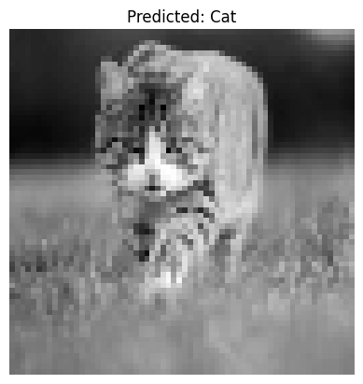

**Inference:**

**1. Image Classification Using HOG and SVM**

* HOG features are effective in capturing shape and texture information relevant for image classification.
* A linear SVM can be a suitable classifier for this task, providing a linear decision boundary.
* The accuracy and classification report provide insights into the model's ability to generalize to unseen data.

**2. Object Detection Using SIFT and Homography (First Instance)**

* SIFT features are robust to scale and rotation changes, making them suitable for object detection in different views.
* The homography transformation can map the reference object to its location in the query image, enabling object localization.
* Successful object detection depends on the presence of sufficient good matches between the keypoints.

**3. Object Detection Using SIFT and Homography (Second Instance)**

* Applying Lowe's ratio test filters out ambiguous matches, improving the robustness of homography estimation.
* Checking for sufficient matches before computing homography prevents erroneous transformations.
* The bounding box drawn on the test image indicates the detected object's location and extent.

**4. Object Detection Using SIFT, Feature Matching, and K-Means Clustering**

* By clustering keypoints in the training image, the code attempts to group points belonging to the same object.
* K-Means clustering provides a simple way to segment the training image into different object instances.
* The bounding boxes represent the spatial extent of each detected object instance.

**Result:**

Outputs image classification accuracy and reports; displays images with detected objects, bounding boxes, and feature matches. May print messages indicating object detection success or failure.